Topic Travel and transport
Level: E2
Time: 140 minutes plus extensions. You may wish to split this lesson over two sessions.

Aims
- To become familiar with all 3 papers of ESOL Skills for Life E2 exams.
- To develop learners’ vocabulary of travel and related language.

Objectives
Learners will be able to/ have made a start to:
- speak and listen using the exam format
- understand exam conditions and some exam instructions
- complete typical reading and writing exam tasks.

Introduction
This lesson is about travel and transport within the UK and beyond. It provides learners with the vocabulary required to understand exam instruction and for the subject of travel. It includes practice for all 3 Skills for Life exams as well as tips about how to improve.
Should you wish to use the lesson plan for another topic in the exam range, substitute the content with the required topic and source relevant reading materials in a variety of genres.

Preparation
You will need:
- Resource 1: to display or large copy and 1 copy cut up for the class (1 picture each)
- Resources 2a, b and 3: to display and 1 copy per learner
- Resources of different genres on the topic e.g. Instructions, leaflets, email, blogs, timetables, etc.
- Exam board handbook
- Past or sample papers
- Assessment guidelines
- Realia relating to travel e.g. holiday brochures, timetables, etc.

Procedure
Warmer (15 minutes)
- Give each learner one picture from resource 1.
- Ask learners to stand up and form a line in order of the cheapest / fastest / most comfortable. To do this they need to discuss the types of transport with each other and compare them.
- Make a note of learners’ vocabulary and language then write useful language on the board, draw learners’ attention to this. Answer any questions and elicit more examples.

Activity 1 – Speaking and listening: journeys (25 minutes)
- Tell learners they are going to talk about a journey they have taken that they enjoyed. This could be using any type of transport.
- Elicit possible questions to ask about the topic e.g. ‘wh’ plus open questions, e.g.: ‘Why did you enjoy it? How long did it take? Who was with you?’
- Explain that these questions help to keep a conversation going and show interest. They are also necessary for the exam.
- Note a few on the board of your own, and those of the learners.
- Put learners in groups of 2 or 3 according to level, and give them a few minutes to think about the journey and to make notes about what they will say.
- Then each learner tells their group about a journey. Invite learners to ask questions.
- While learners are speaking, make a note of appropriate grammar, questions and vocabulary e.g. use of comparatives, present simple and continuous, wh questions etc. and share with the whole group as feedback.
Differentiation/ extension
- If learners cannot think of a journey they enjoyed, they could talk about which transport they most enjoy and why or advantages and disadvantages of types of transport.
- If your learners do not know how to make notes, elicit some ideas and how to write them as notes e.g. if someone says ‘I went to London by car’ write, London – car. Ask learners to suggest some possible abbreviations e.g. &, imp. (important), etc.
Activity 2 – writing - journeys (20 minutes)
- Explain they will be required to write up to 50 words on a subject for the exam.
- Elicit a few things that you need to remember when writing e.g. use capital letters and full stops, correct word order, using the correct tense, etc.
- Write some of the notes from 1 of the learners on the board and elicit a few sentences.
- Elicit an appropriate opening sentence for the writing.
- With learners still working with their partner (who should be of a similar level), ask them to work together to write a few sentences from their notes. While they are doing this support the weaker learners.
- Ask 2 or 3 learners to write 2 sentences on the board and get all learners to check for correct use of punctuation, tense, etc.
- You could write some sentences with typical common mistakes learners have made as well.
- Elicit conjunctions: and, but, so, because. Write them on the board.
- Ask learners to link some of the sentences on the board e.g. ‘I travelled to Spain by train.’ add ‘and I liked it.’
- Continue until all conjunctions have been used. Cross them out as you do this.
- Ask learners to join some of their sentences together using and, but, etc,

Differentiation
- Higher level learners: write the story using 2 or more paragraphs, including past tenses and appropriate grammar.
- Ask learners to finish their story for homework with up to 50 words and at least 3 sentences plus opening and closing sentences. At the start of the next session get learners to peer correct each other’s work.
Activity 3 – Reading: exam conditions (15 minutes)
- Ask learners to discuss rules for exam conditions in pairs or small groups.
- Elicit some answers and make a checklist on the board. Possible answers:
  - no talking
  - no looking at other’s papers
  - no leaving the room;
  - raise your hand to ask a question.
- Elicit what would happen if you copy.
- Ask learners to discuss some tips for doing well in the exam in pairs or small groups. They should write some sentences.
- Nominate one learner from each group to write a sentence on the board. Possible answers.
  - Look at all the exam questions before you start so you can decide how much time to spend on each section.
  - Move to the next section when that time is finished.
  - Don’t spend too much time on each section - make sure you write something for every section as you can come back to it later.
  - When you have finished, go back and complete anything you didn’t finish.
  - Check for spellings and grammar at the end.
Activity 4 – Reading exam (20 minutes)
- Display resource 2a and ask learners questions to elicit features of the text such as: ‘What kind of text is it e.g. advert, leaflet, etc. How can you tell? What do the headings/ subheadings do? How do the pictures help?’
- Give out resource 2a and instruct learners to complete independently under exam conditions. Set a time limit of between 5-10 minutes, dependent on your learners’ ability. If possible, move the seating so it is like an exam room.
- Get learners to discuss the following questions in pairs: How was it using exam conditions? Did they follow the tips suggested before? What problems did they have? How could they get better?
- Elicit some of the skills the exam tests e.g. putting words in alphabetical order, saying type of text, finding spelling mistakes, dictionary use, answering questions about something you have read.

Tip! Practise these techniques on a regular basis:
- dictionary use – spend a few lessons teaching how to use a dictionary i.e. skimming for word then focus on definition and example;
- alphabetical order / dictionary use – do as a warmer / cooler to recap new vocab;
- genre – regularly discuss when doing reading activities;
- spellings – give learners spellings of 10 words a week to learn then have do spelling test.
- Handout resource 2b and complete under exam conditions for further practice.
- Upon completion get learners to check each other’s papers.
- Feedback correct answers and discuss any tricky questions.
Activity 5 – Speaking, listening, reading and writing: form section (20 minutes)
- Display resource 3 and elicit the parts of the form. Check learners understand e.g.:
- vocabulary for names – surname/ family name/ last name;
- UK address and postcode – if they don’t have an English address, assist them to make up an easy one to spell;
- telephone numbers with 11 digits starting with ‘0’;
- email address (assist to make):
- date of birth.
- Learners then ask each other questions to get the information needed to complete resource 3. Elicit questions to ask for name, address and telephone number, and spelling.
- Monitor and feedback any issues after learners have finished.
- Now ask learners to complete resource 3 under exam conditions.
Differentiation
- Resource 2b and 3 can be completed as homework if time is short.
Cooler 1 (10 minutes)
- Put learners into mixed groups of about 3. Write these words on the board: and, but, so, or, because, firstly, secondly, finally, bigger, better, faster, slower.
- Ask teams to write a sentence using at least one of the words.
- The team with the youngest learners starts. They should write their sentence on the board. Other teams should correct if necessary.
- They get 1 point per word used and lose 1 point for each mistake.
Cooler 2 – Carry on my sentence (15 minutes)
- Start by saying ‘In the summer I went to the mountains …’
- Invite a learner to use one of the words on the board and add a complement. For example ‘… and had a lovely day.’
- Invite the next learner to choose a word from the board and continue the story. For example, ‘First I had an ice cream…..’
- Continue this until all learners have had a turn, or you have used all the words.
- When the word has been used, delete it to ensure all vocabulary items are practised.
Differentiation
- Vocabulary items can be varied to meet higher and lower levels according to the core curriculum. Use as few or as many words as is appropriate to your group.
- You could use one of the coolers as a warmer in a following lesson.

Extension activities/ Homework
- Learners can complete additional written tasks for homework on other topics from exam board past/ example papers. Go to website to download.
- Ask learners to go to the library and find out about travel in the UK or other exam subjects.
- Additional reading tasks can be presented through authentic sourced materials and asking comprehension questions similar to those in the exam, on a range of topics.
Tip! The more exposure the learners have to a variety of texts, the better prepared they will be, both for the exam and real life.

Resource 1

 |  | 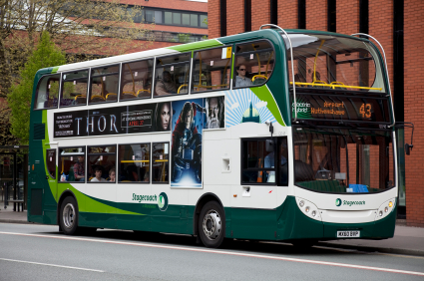
 | 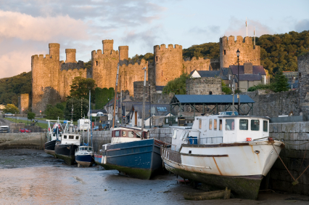 | 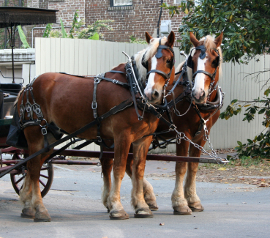
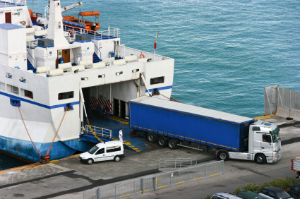 |  | 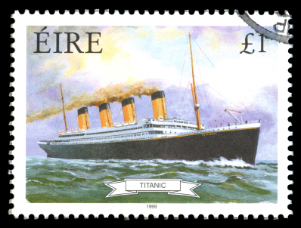
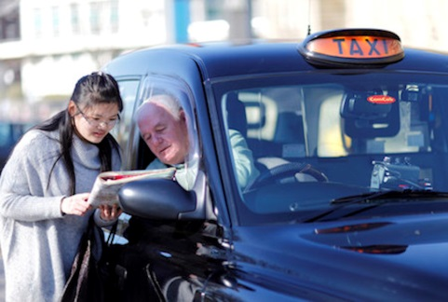 | 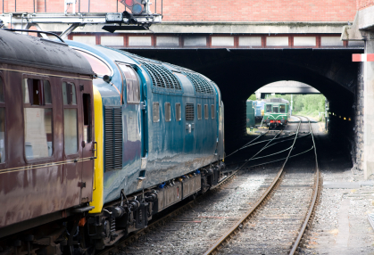 | 

Resource 2a
BOAT train Car arrival

Plane DEPARTURE

- Put the words in the box in alphabetical order.
____________ _____________ ______________
____________ _____________ ______________

- Look up the meaning of ‘departure’ in you dictionary.
____________________________________________________________________________________________________________________________

TRAVEL UK LTD
a
River Cruise
Take a relaxing trip along the River Thames. You can party the night away on a disco boat or enjoy a leisurely meal and see some of London’s most famous buildings: Tower Bridge, Houses of Parliament, or even the Millennium Wheel!
Lake District
this is a great trip for people who like walking. You can relax the moment you step on the bus, and when you arrive at the Bed and Breakfast, you will love the views, but don’t get too comfortable because to enjoy the lakes, you must go out and walk!

b


Cities
We have 3 city trips planned this summer: Edinburgh and York in the north and Bristol in the south. Each city has something special to offer from good food and wine, to fabulos architecture from years gone by and modern day. Sit back and enjoy the train journey or dine in the restaurant car; the choice is yours

c


Timetable
Month Bus Boat Train

June Lake District X Bristol

July Lake District River Disco Edinburgh

August Lake District River Dining York

d


For more information contact Bill 07458 231884 or fill out the application form.

Resource 2b
- The text gives you information about
  - Holidays
  - Trains
  - Transport
- Match the pictures down the side to the correct text. There is a spare picture.
  - Lake District picture ____
  - Cities picture____
  - River Cruise picture ____
  - Spare picture picture ____
- Find the spelling mistake in ‘Cities’.
_____________________________

- Find the punctuation mistake in ‘Cities’
______________________________________

- Which sentence should start with a capital letter in ‘Lake District’?
____________________________________________________

- Which trip does not run in June?
____________________________________________________

- When can you go to Bristol?
____________________________________________________

- Which month can you go on a disco boat?
____________________________________________________

- Where should you go if you like walking?
____________________________________________________

- Where can’t you have a meal?
  - Bus
  - Train
  - Boat
- What number should you phone to get more information?
____________________________________________________
- The text is a
  - Letter
  - Advert
  - Information

Resource 3
Travel UK LTD
Information request form

Please complete and return to: 99 run way, London, NW9 and we will post out the information you require.

Title
First name(s)
Family name
Address
Postcode
Telephone number
Email address
Date of birth
I would like more information about
- Lake District

- Cities

- River trips

Please tick 1 or more boxes.

Answer key

Resource 2a and b
- arrival, boat, car, departure, plane, train.
- a
- a-c, b-b, c-a, d-d
- fabulous
- End of the paragraph
- Opening sentence
- Boat
- June
- July
- Lakes
- a
- Bill 07458 231884
- b

